Name: Jamie Anthony Brindle
Student ID: 06352322
Title: Website Development: Online Bookshop Assignment 1 Demonstration and Testing
Reading List Search, Online Help, Loggin Out

Reading List: Search books under a specific reading list
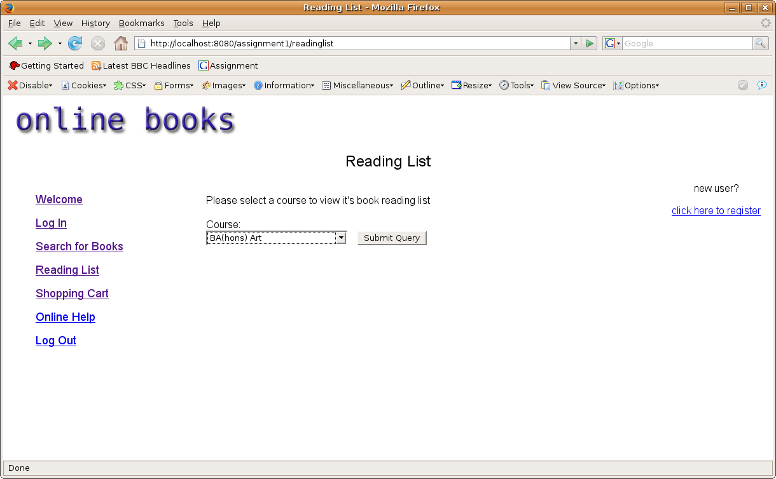
Search for a book reading list be selecting the course from a drop down menu

Reading List: Results: English
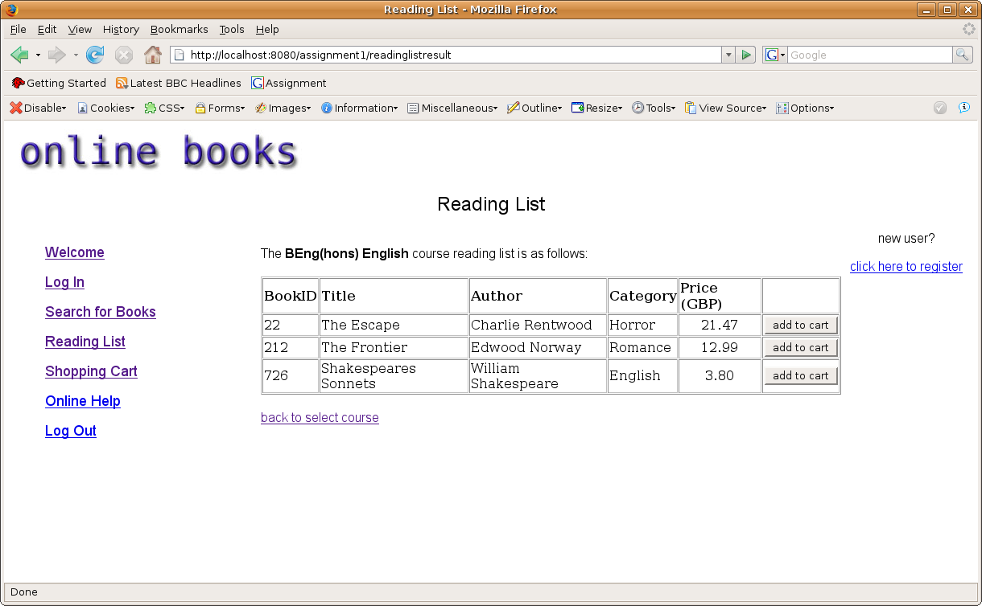
Books for that reading list appear, confirming the selected course and giving the option to add the book to a shopping cart
Reading List: Adding to cart
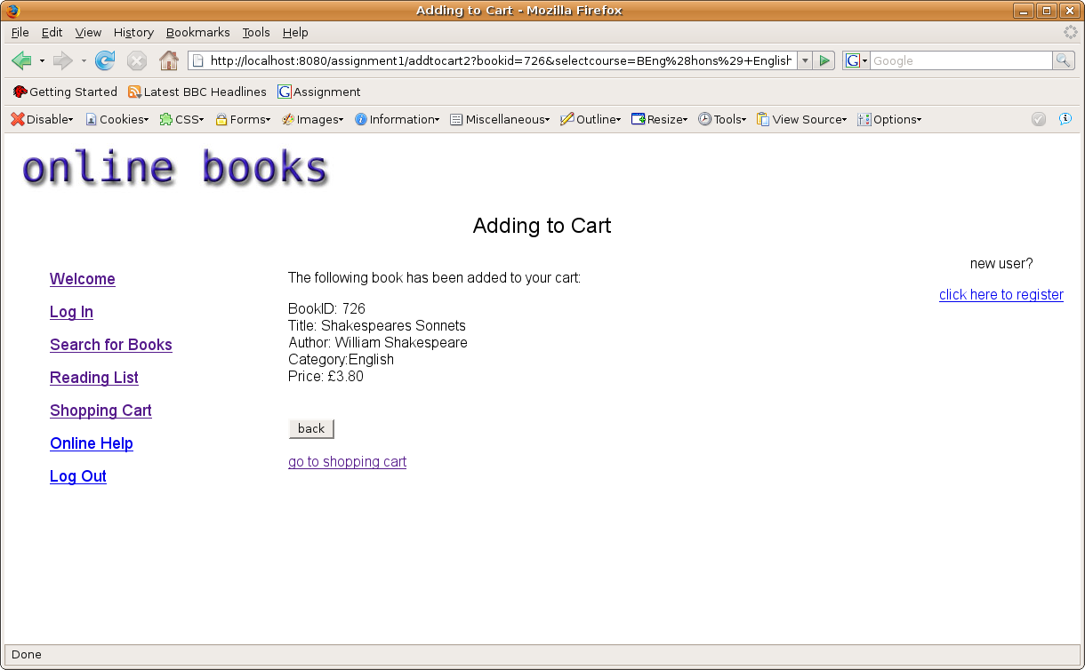
Confirms that the book has been added to the cart, also gives the option to go back to the selected reading list in case the user wishes to order more books from the same reading list

Reading List: 'Back' button after cart addition confirmation
Previous reading list brought back up successfully

Adding to Cart: Double check book has been added to cart:
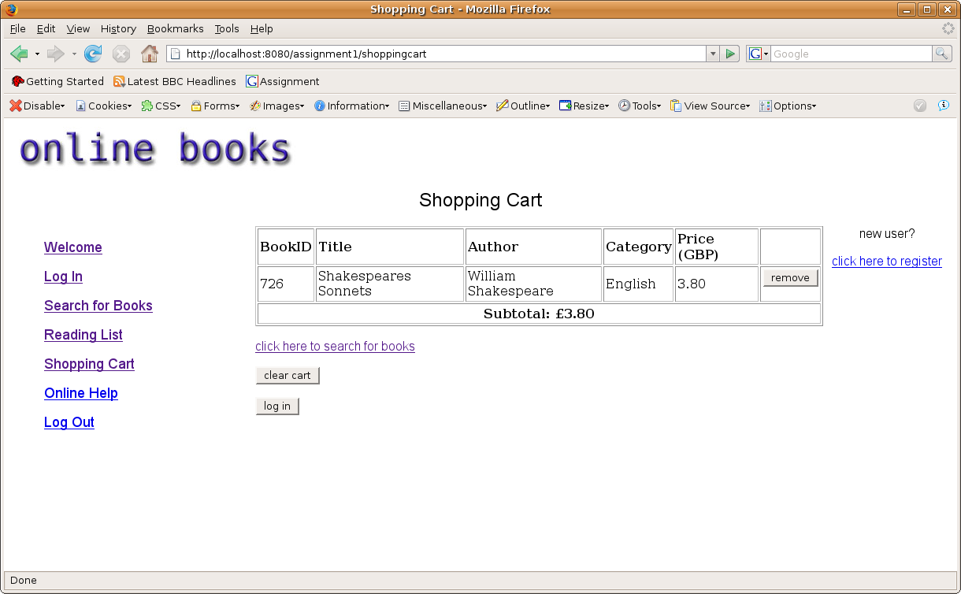
Book successfully been added to cart

Online Help: Displays general help and information about the site:
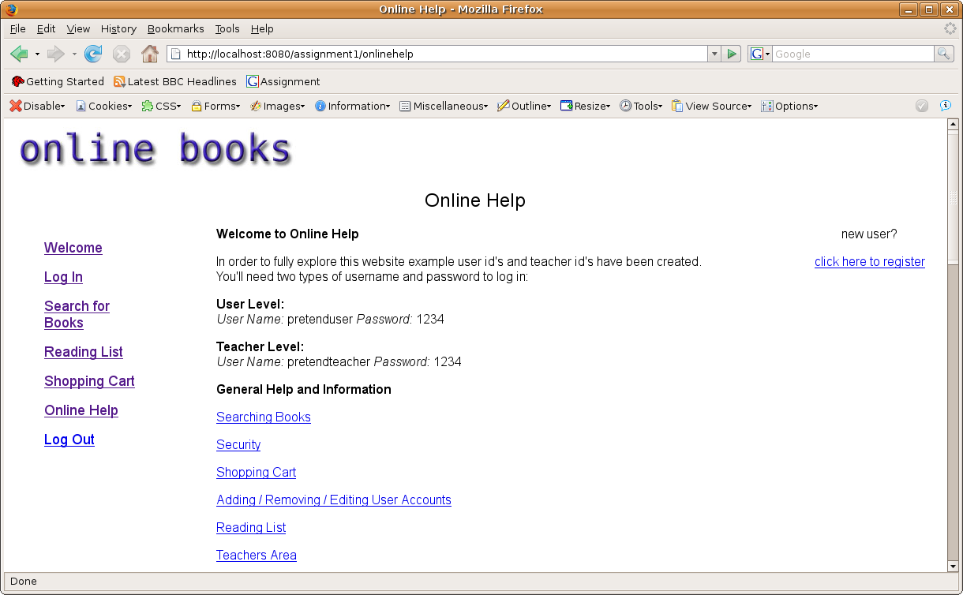
Shows help with links to the same page for ease of searching for requested information

Online Help: Links: Shopping Cart
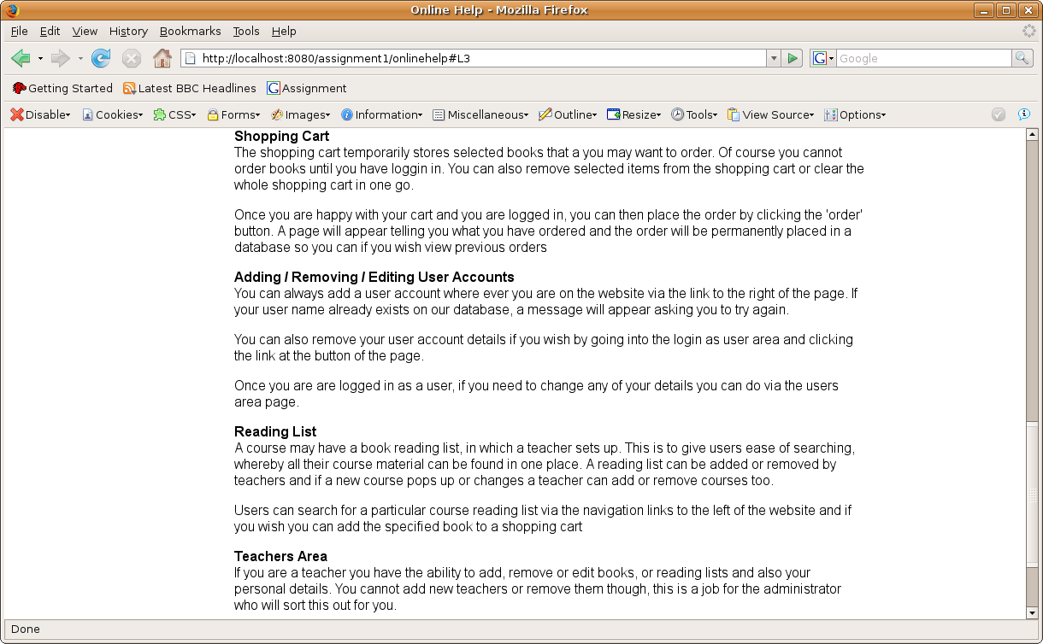
All links work successfully, however not all screen shots are shown, only an example

Logging Out: Clears all session cookies, logging the user out of the site: pre: cookie information
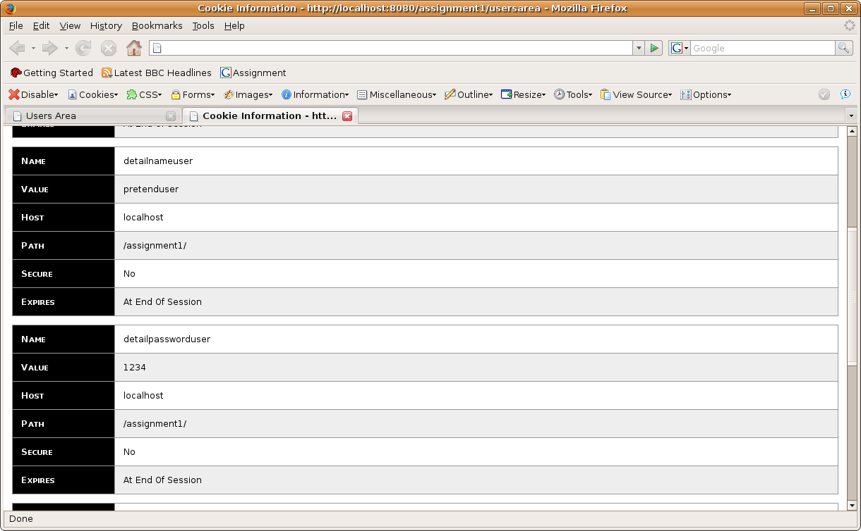
User session cookies include: user name of user, password of user, a user validation cookie

Logging Out: Confirmation
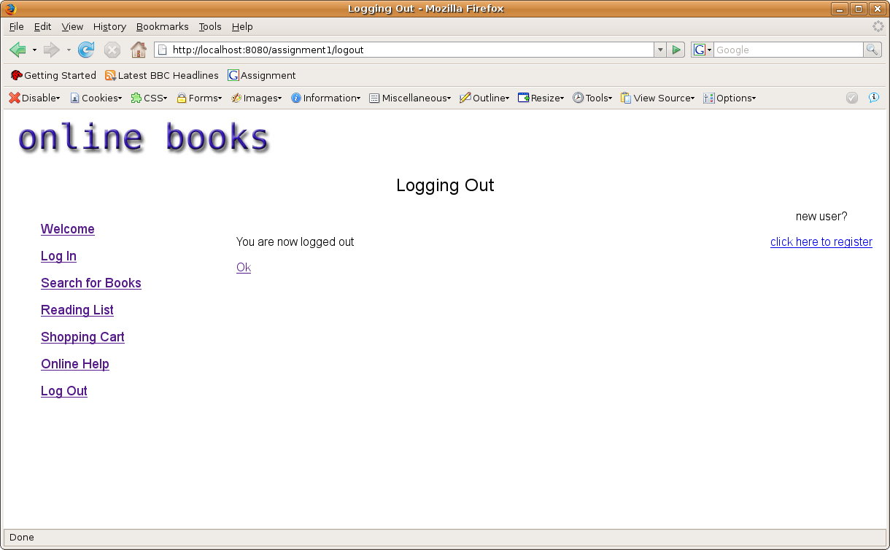
Confirms user is logged out, the 'ok' button sends the user back to welcome page

Logging Out: Session cookies cleared (or expired): post
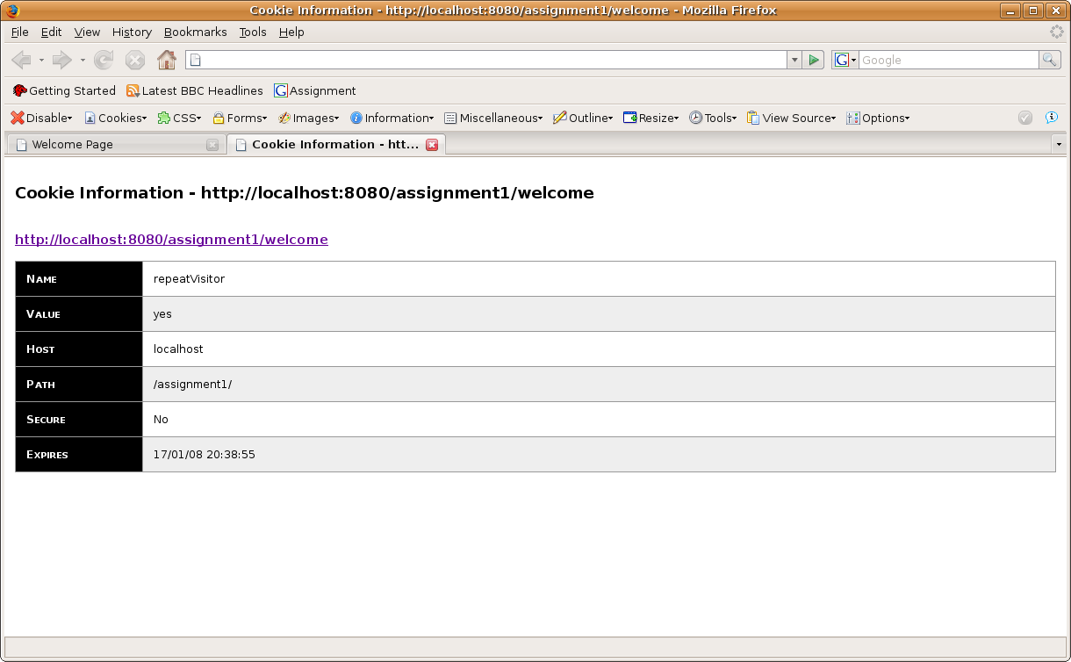
listed session cookies expired – The cookies to be expired are in the form of a list, when the user or the teacher logs out, these cookies are expired

